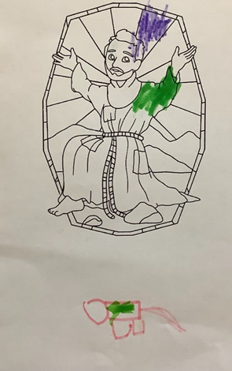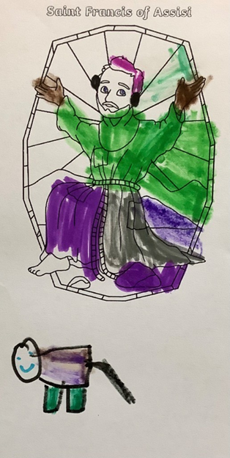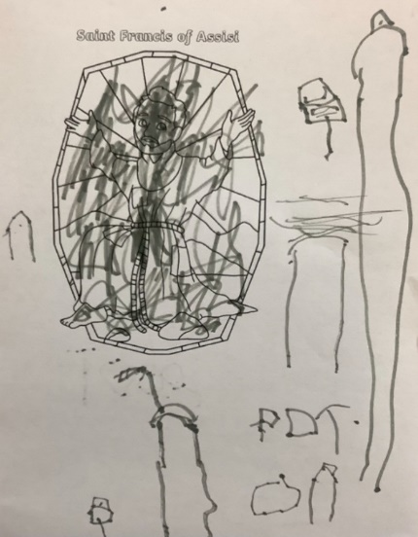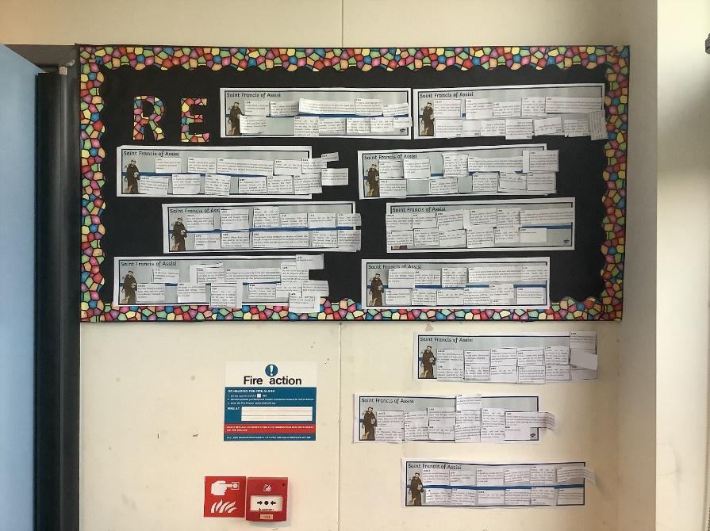

'I think he must have seen how some people were looking after the world and said well done to them' Sophia

'I think he would feed the animals and make sure there wasn't any litter around that they could eat accidentally' Theo

'He didn't need his own things because he just looked after other people and their animals'

Charlie

'Francis wanted us to look after our world'

Aarya

'I think he would feed the animals and make sure there wasn't any litter around that they could eat accidentally' Theo

St. Francis of Assisi

On Wednesday 4th October, the whole school commemorated the life of St. Francis of Assisi who is one of our Saints linked to our school and church.

He was born in the 12th Century and is the Patron Saint of animals and the environment.

Have a look at some of our wonderful work!