Year Group - 5 |  | Term – Autumn 2 |  | Educating for Wisdom, Knowledge and Skills To help grow resourceful, resilient and reflective children who are equipped with the skills, knowledge and tenacity empower themselves, their learning throughout their lives.  Educating for Hope and Aspiration To inspire and enrich lives beyond current opportunities and experiences in order to open minds to the potential their future holds  Educating for Community and Living Well Together To be a multi-cultural, inclusive community of individuals loved by God who feel valued and involved where we create qualities of character to enable people to flourish.  Educating for Dignity and Respect That children might know how much that they are loved and valued by so that they might show dignity and respect for themselves and others by carefully and safely thinking through their actions.
Name of Unit Overview –

Space
Context, Big Questions and Wider World impact
- Where in Bracknell would we build a space port?
- What are the features needed to build a successful space port?
- How can I transport an object, causing the least amount of friction?
- Which shape creates the least water resistance?
- How do we know that the Moon landings happened?
- What are the features of Peacocks Meadows?
Subject specific learning areas
Science |  |  |  |  |  |  | Suggested journey of the unit
Prior learning and where the objectives are revisited later in the year. |  |  | Key year group learning  Can we…….? Do we know……..?
Working scientifically in KS2  - asking relevant questions and using different types of scientific enquiries to answer them  - setting up simple practical enquiries, comparative and fair tests  - making systematic and careful observations and, where appropriate, taking accurate measurements using standard units, using a range of equipment, including thermometers and data loggers  - recording findings using simple scientific language, drawings, labelled diagrams, keys, bar charts, and tables  - reporting on findings from enquiries, including oral and written explanations, displays or presentations of results and conclusions  - using results to draw simple conclusions, make predictions for new values, suggest improvements, and raise further questions  - using straightforward scientific evidence to answer questions or to support their findings  Year 3:  - compare how things move on different surfaces  - notice that some forces need contact between 2 objects |  |  | Can we…?  - create a dinghy that will travel quickly whilst staying afloat  - describe the phases of the Moon  - make predictions about different surfaces and the amount of friction they will create  Do we know…?  - the effects of water resistance and friction, that act between moving surfaces  - that different types of surfaces create varying amounts of friction  - that friction and water resistance are forces  - that a larger surface area increases the amount of water resistance that an object receives |  |  |  | - Exploring the phases of the Moon and recording these.  - Learning about friction. Conduct an investigation using a Newton meter to record the amount of friction each material creates. Which would be the most effective material to place under our space shuttle to transport it easily?  - Learning about water resistance and streamlining. Investigation into dinghies that will create the least amount of water resistance, to transport our astronauts once they have landed safely in the sea.  - Looking at primary and secondary sources about the Moon landing. Pupils identify whether the artefact is a primary or secondary source, state the validity of the source and whether it helps to inform us about the space race.  - Research into Bracknell and Wokingham and deciding which would be the best area to put a space port in.  - Writing a persuasive letter to Richard Branson, persuading him to build a space port in their chosen area.  - Fieldwork lesson – trip to Peacock Fields to investigate more into Bracknell, and pick a precise spot to put the space port (using grid references and maps).  - Learning about Peter Thorpe and creating a background in his style (imitate).  - Continuing with backgrounds and using chalk pastels to create depth and texture.  - Creating the rocket (focal point) in the style of Peter Thorpe  - Assembling their picture and evaluating their work  - Research into 3 different websites, each of which give slightly different information on Kstherine Johnson, and deciding which one is the most reliable and why.  - This research then links to English biography – on Katherine Johnson.
Humanities – History & Geography
Prior learning and where the objectives are revisited later in the year. |  |  | Key year group learning  Can we……..? Do we know…..?
Revisit within this year  Geography:  - Use maps/globe/atlases to locate continents and countries  - Symbols and keys  - Name, locate and identify: continents and main countries  History:  Year 4:  - To describe a range of historically significant and reliable sources of evidence  - To ask and answer historical questions  Year 3:  - To explain how we use primary sources to develop our understanding |  |  | Geography  Can we…?  - Describe the differences between two places in the local area, and how these would differ with making a space port.  - Plot on a map the best location for a space port, and justify these choices.  Do we know…?  - How to use 4 figure grid references to plot a map of a local field.  - How to explain where items are on a map using grid references.  History  Can we…?  - Identify how we can use primary and secondary sources to help us find out about key events  - Identify key artefacts from the time Space Race and explain whether they are useful in finding out about this time period  Do we know…?  - Why the Space Race happened and who it involved  - Several primary and secondary sources about the Space Race  - That we need to look at a range of factors when interpretating a piece of evidence, and to ask key questions
Art and Design & Design Technology
Prior learning and where the objectives are revisited later in the year. |  |  | Key year group learning
Revisited within Year 5  - Blending paints to create an atmosphere  - To explore how the use of complementary and analogous colours to create different effects and moods  - To use a range of artistic painting tools to create different paint effects  - Sketching our designs, and using methods to create texture and shading  - Critiquing an artist |  |  | Art  Peter Thorpe  Can we…?  - Layer textures  - Blend chalk pastels  - Apply a variety of implements to create different effects  - Describe the features of abstract expressionism  - Review and evaluate our artwork  Do we know…?  - What abstract expressionism is  - Who Peter Thorpe is and how he contributed to abstract expressionism  - How abstract expressionism was established
Computing and Technological Understanding
Prior learning and where the objectives are revisited later in the year. |  |  | Key year group learning
Revisit within this year  - understand computer networks, including the internet; how they can provide multiple services, such as the World Wide Web, and the opportunities they offer for communication and collaboration  - use search technologies effectively, appreciate how results are selected and ranked, and be discerning in evaluating digital content |  |  | Can we…?  - Use a search engine to find sources of information on Katherine Johnson?  - Understand how different websites show us different kinds of information, and how this affects our understanding.  Do we know…?  - How to use a search engine to find information
Vocabulary  Oracy activities | - Primary and secondary sources  - Artefacts  - Friction  - Streamlined  - Abstract expressionism  - Complementary and analogous colours  - Validity  - Provenance  - Waning and waxing  - Crescent  - Phases  - Use bagel thinking – challenge 10 toolkit |  |  | Immersion Activity- What do they need to know? How are you going to motivate and inspire learning within the topic? |  | - Planetarium visit  - Zoom call with satellite engineer, who creates satellites that are launched into space  - Wintershall in school
 |  |  |  | Trips/ Visits / Experiences |  | - Zoom call with an engineer who manufactures satellites which are launched into space  - Visit to Peacock Meadows  - Planetarium visit in school
Discrete subject learning focus areas
Music | 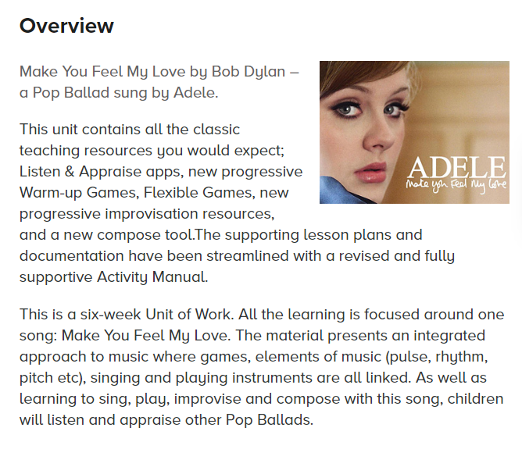 |  |  | RE |  | 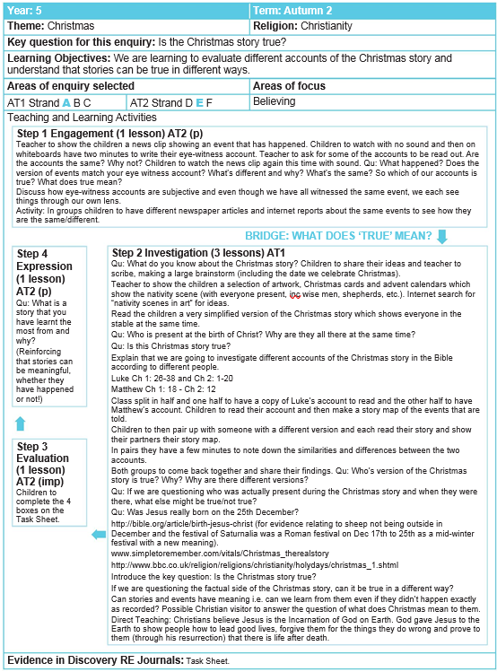
PE | Real PE: Social  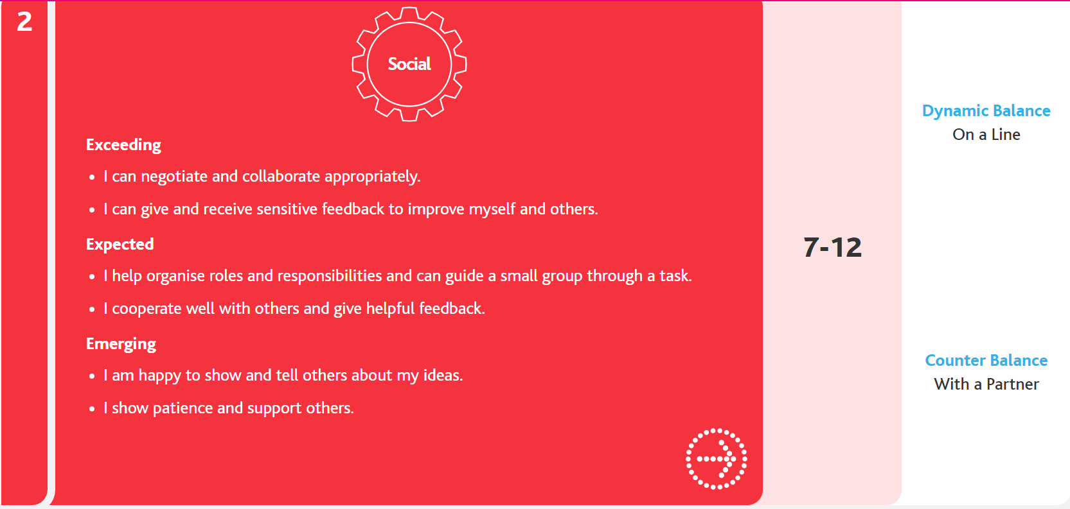 |  |  | PSHE |  | - To understand and list the attributes of a good friend  - To identify the qualities of a good friend  - To consider the rights and responsibilities we have in friendships  - To explain what peer pressure is and know ways to challenge it  - To explain the possible repercussions of feeling excluded  - To know where to turn in times of unhappiness or when witnessing something you are unsure about  - To explain what makes a situation fair or unfair  - To explain what it means to belong and explain why belonging is important  - To identify places we feel we belong  - To explain what it means to belong and explain why belonging is important  - To identify places we feel we belong  - To explore gender stereotypes  - To explain why it is important to challenge gender stereotypes
Final quality products | - Abstract expressionist space artwork in the style of Peter Thorpe  - Poem which children record on Seesaw  - Sci-fi story which chn write |  |  | Home learning opportunities |  | - Research into the Moon landing, and different space shuttles that have successfully launched  - Research into satellites in space ready for zoom call
Enriching our curriculum and personal development opportunities
Prior opportunities | Experience |  |  |  | Learning to come from those activities
 | - Diwali dance workshop  - Pause day  - Mindfulness workshops  - Friendship week |  |  |  | From these activities, children will further develop their independence, collaboration, perseverance and optimism. They will also learn how to challenge themselves in an environment outside of the classroom. This should further develop their self-esteem and confidence, and deepen their understanding of the Year 5 curriculum, and our school values.

