Year Group - 5 |  | Term – Autumn 1 | Educating for Wisdom, Knowledge and Skills To help grow resourceful, resilient and reflective children who are equipped with the skills, knowledge and tenacity empower themselves, their learning throughout their lives.  Educating for Hope and Aspiration To inspire and enrich lives beyond current opportunities and experiences in order to open minds to the potential their future holds  Educating for Community and Living Well Together To be a multi-cultural, inclusive community of individuals loved by God who feel valued and involved where we create qualities of character to enable people to flourish.  Educating for Dignity and Respect That children might know how much that they are loved and valued by so that they might show dignity and respect for themselves and others by carefully and safely thinking through their actions.
Name of Unit Overview –

Space
Context, Big Questions and Wider World impact
Where in Bracknell is suitable for a space port?
What is the most important event in the space race?
How are the planets held in space?
What are time zones?
What is the most effective shape for a space shuttle?
Subject specific learning areas
Science |  |  |  |  |  | Suggested journey of the unit
Prior learning and where the objectives are revisited later in the year. |  | Key year group learning  Can we…….? Do we know……..?
Working scientifically KS2:  - asking relevant questions and using different types of scientific enquiries to answer them  - setting up simple practical enquiries, comparative and fair tests  - making systematic and careful observations and, where appropriate, taking accurate measurements using standard units, using a range of equipment, including thermometers and data loggers  - recording findings using simple scientific language, drawings, labelled diagrams,  keys, bar charts, and tables  - reporting on findings from enquiries, including oral and written explanations, displays or presentations of results and conclusions  - using results to draw simple conclusions, make predictions for new values, suggest improvements and raise further questions  - using straightforward scientific evidence to answer questions or to support their  findings. |  | Can we…?  - Describe the movement of the Earth and other planets relative to the solar system  - Identify the effects of air resistance that acts between moving surfaces  - Describe the different properties of the planets in our solar system.  Do we know…?  - That the Sun, Moon and Earth are approximately spherical bodies.  - That the planets orbit the Sun.  - That the distance of a planet from the sun affects the length of its orbit. |  |  |  | - Features of the planets and creating a model of the solar system.  - Investigation into shadows and the movement of the Earth using software to create graphs and tables to record our results.  - Investigation into air resistance and how gravity effects the speed and distance objects travel.  - Understanding why the space race started, and learning about when the key events took place.  - Researching a specific event in the space race and creating a multimedia presentation.  - Share presentations and create key notes on each event.  - Learning about the planets and their locations in space and physical and human characteristics (links with science)  - Deep dive into 3 space centres across the world, note taking on sheets to create a comprehensive view of the key geographical features.  - Project with Mexico – creating powerpoints about time zones and presenting to Peterson school.  - Critique an artist (Van Gogh)  - Mixing colours and painting in an impressionist style.  - Learning how to paint in a stippling style.  - Learning how to create texture in art.  See history planning as there is a crossover between computing and history.
Humanities – History & Geography
Prior learning and where the objectives are revisited later in the year.  Year 3:  - To ask and answer questions about how technology changed the world and whether it was for the better or worse  - To know that advances in technology have moved quickly and are still evolving daily.  Year 4:  - To understand the importance of British involvement in world exploration both past and present (including space exploration)  - To compare a range of texts that help us to picture life in the past. To know which types of evidence sources are the most important to our knowledge |  | Key year group learning  Can we……..?  - To know when, why and how the Space Race began and who was involved.  - Look at the representation and importance of women in the space race and how their roles progressed- Hidden figures- and how this affected women’s roles in this industry.  - To describe the key events in the space race (eBooks created on each key event by groups of chn)  - To ask and answer historical questions about the Space Race and key events.  - To examine a range of historically significant sources of evidence of key events of the Space Race and the validity of the evidence: e.g. videos of Neil Armstrong in space, photos from the satellites, newspaper reports etc. Primary and secondary sources and how these are reliable.  Do we know…..?  - The events that took place in the space race, and why these were historically important.  - The chronological order of the events in the space race.  - The importance of women in the space race and how they contributed.
Prior learning:  Year 3:  - Significance of the Equator  - Geographical similarities and differences between local area, a region in an EU country.  - Use maps/globe/atlases to locate continents and countries. Use 8 point compass and basic key and symbols of maps. Fieldwork of local area surrounding school Including sketches, maps, plans and graphs.  Year 4:  - Areas of similar climate e.g. rainforests, arctic, desert.  - Climates zones, biomes and vegetation belts.  - Use maps/globe/atlases to locate continents and countries. Use 8 point compass and basic key and symbols of maps. Fieldwork of local area surrounding school Including sketches, maps, plans, graphs and digital technology. |  | Geography  Can we…?  Continents, main countries including N and S America. Significance of GMT .  Geographical similarities and differences between local area, a region in an EU country and a region in North or South America.  Use maps/globe/atlases to locate continents and countries. Use 8 point compass, 4 figure grid references, symbols and keys. Fieldwork of local area surrounding school Including sketches, maps, plans, graphs and digital technology.  Do we know…?  - Significance of GMT- link to space and the time zones  - The significance of the equator  - How different climate zones and biomes contribute to a space centre’s success  - How to read 4 figure grid references and use these to contribute to their understanding.
Art and Design & Design Technology
Prior learning and where the objectives are revisited later in the year. |  | Key year group learning
Prior learning:  Year 3:  - Use a sketchbook to record media explorations and experimentations as well as planning and collecting source material for future works.  - Create textures and patterns with a wide range of drawing implements.  - Use light and dark within painting and begin to explore complimentary colours.  - Mix colour, shades and tones with increasing confidence.  Year 4:  - Draw for a sustained period of time at an appropriate level.  - Use sketchbooks to collect and record visual information from different sources as well as planning and colleting source material for future works.  - Have opportunities to develop further drawings featuring the third dimension and perspective.  -Start to look at working in the style of a selected artist (not copying). |  | Art – Painting on a canvas (Van Gogh)  Paint: Painting (stippling)  Designer: Van Gogh  - Learn about great artists, architects and designers in history: Van Gogh  - Improve their mastery of art and design techniques: drawing and collage  - create sketchbooks to record their observations and use them review and revisit ideas
Computing and Technological Understanding
Prior learning:  Year 3:  - Increasing speed and accuracy with typing: -use index fingers on keyboard home keys (f/j) -use left fingers for a/s/ d/f/g, and use right fingers for h/j/k/l  - edit the style and effect of my text and images to make my document more engaging and eye-catching. For example, borders and shadows. -use cut, copy and paste to quickly duplicate and organise text.  -Start to input simple data into a spreadsheet.  Year 4:  - Creating algorithms  - Type and design a variety of documents, posters and leaflets using ICT. Learn rules for creating neat word processed work.  - Confidently and regularly use text shortcuts such as cut, copy and paste and delete to organise text  - Use font sizes appropriately for audience and purpose.  - Use spell check and thesaurus including through Siri and other AI technology  -Produce a multimedia video topic about topic with music and narration. |  | Key year group learning
Can we…?
Enter formulae into a spreadsheet to solve calculations and model scenarios, including using =SUM() and statistical functions.
• Change the format of cells of cells using: text alignment, borders and data types. Children develop the excel spreadsheet skills to record a data handling project
• Create a multimedia on-screen presentation over several slides, adding animation and transition effects to enhance it.
- Compare techniques used for manipulating and putting pressure on people online.

Do we know…?
- What online hazards are and how to respond to them safely.
- The term ‘digital footprint’ and describe strategies for reducing it.
- How to stay safe when watching and recording videos online.
- How to safely send digital messages.
- How to design and make a multi-media presentation about a learning topic or them self.

Vocabulary  Oracy activities | Vocab: solar system, geocentric, heliocentric, spherical, gravity, orbit, revolution, rotation, axis, space race, digital footprint, digital, stippling,  Challenge 10:  Visual thinking  Quality criteria  Bagel thinking |  | Immersion Activity- What do they need to know? How are you going to motivate and inspire learning within the topic? |  | - Local area fieldwork (geography trip)  - Paint and create solar systems
 |  |  | Trips/ Visits / Experiences |  | - Visit to Peacock fields  - Planetarium in school
Discrete subject learning focus areas
Music | 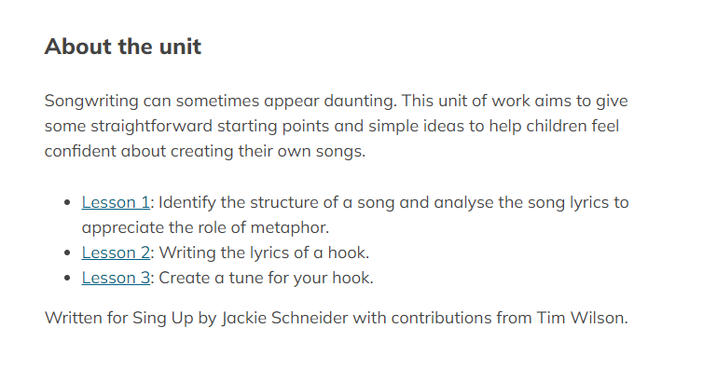  Sing Up: Why we sing |  | RE |  | 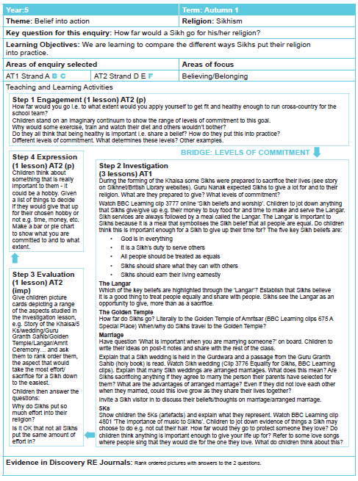
PE | Football  -Dribbling  -Passing  -Scoring goals  -Teamwork  -Rules of the game |  | PSHE |  | - To understand and list the attributes of a good friend  - To identify the qualities of a good friend  - To consider the rights and responsibilities we have in friendships  - To explain what peer pressure is and know ways to challenge it  - To explain the possible repercussions of feeling excluded  - To know where to turn in times of unhappiness or when witnessing something you are unsure about  - To explain what makes a situation fair or unfair
Final quality products | - Painted solar systems with explanations on seesaw  - Multi media presentations on the space race  - Persuasive pieces on seesaw about their chosen planet  - Audio and setting description written up neatly |  | Home learning opportunities |  | - Research solar system at home (BBC Bitesize)  - Recording moon phases as homework.  - Literacy writing opportunities
Enriching our curriculum and personal development opportunities
Prior opportunities | Experience |  |  | Learning to come from those activities
 | - Felt making  - Quiz club  - Theatre in school production  - Planetarium visit  - Visit to Peacock meadows |  |  | From these activities, children will further develop their independence, collaboration, perseverance and optimism. They will also learn how to challenge themselves in an environment outside of the classroom. This should further develop their self-esteem and confidence, and deepen their understanding of the Year 5 curriculum.

