Jennett’s Park CE Primary School

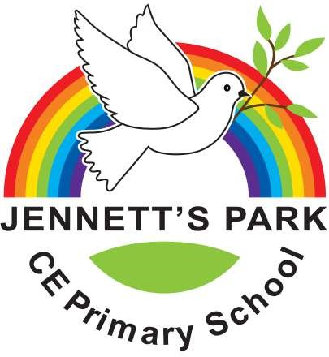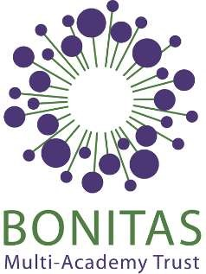

Head Teacher: Mrs Elizabeth Savage

3 Tawny Owl Square, Jennett’s Park, Bracknell RG12 8EB

T: 01344 301269

secretary@jennetts.bonitas.org.uk

5.12.24

**IMPORTANT: Information on Pupil Premium Funding**

Dear Parents and Carers,

We are writing to you about support which is available for families who may find themselves in financial difficulties temporarily or longer term. The cost of living crisis has led nationally to an increase in the number of households eligible for Universal Credit. This has led to an increase in the number of children successfully applying for Free School Meals Funding. We believe it’s important to provide the necessary support to every family in our school community. As a part of this, we think it’s important to provide clear information so that every family is able to get the financial support they are eligible for.

Universal Infant Free School Meals vs Free School Meals

We understand there is some confusion between these two very similar terms. Universal Infant Free School Meals (UIFSM) are available to all pupils in reception, year 1 and year 2. Funding is provided to the school directly, and is used by the school to provide free school meals to infants at UK schools.

Free School Meals (FSM), on the other hand is financial support provided to children of families who fall under certain qualifying criteria highlighted below. While parents may not need to apply for FSM for their child if the child is still young enough to receive UIFSM, it is still important to tell the local authority if your family falls under any of the qualifying criteria. This is vital because if you qualify you will be able to receive free school meal vouchers over the summer and in the event of school closures. Additionally, schools only receive pupil premium funding for every child registered for FSM.

Applying for FSM funding, if you are eligible, can make a huge difference to your own financial situation. It also allows schools to access additional funding which is used in a variety of ways to support students in school such as funding hot meals, resources and possibly school trips. There is no shame in accessing this funding and it can help to improve the outcomes for young people throughout their school lives and beyond. We know that circumstances can change and that whilst you may not have been eligible in the past you now may well be. If after reading the criteria below you think you may be eligible you can complete an application form here https://www.bracknell-forest.gov.uk/schools-and-learning/schools/free-school-meals

Your child may be able to get free school meals if you receive any of the following:

* Income Support
* Income-based Jobseeker’s Allowance
* Income-related Employment and Support Allowance
* Support under Part VI of the Immigration and Asylum Act 1999

 

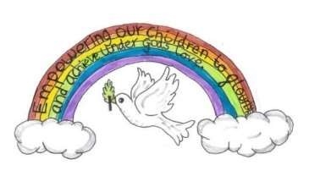

1 | P a g e

* The guaranteed element of Pension Credit
* Child Tax Credit (provided you’re not also entitled to Working Tax Credit and have an annual gross income of no more than £16,190)
* Working Tax Credit run-on - paid for 4 weeks after you stop qualifying for Working

Tax Credit

* Universal Credit - if you apply on or after 1 April 2018 your household income must

be less than £7,400 a year (after tax and not including any benefits you get)

Families who are entitled to support through the FSM/Pupil Premium (PP) Funding are supported in a number of ways at Jennett’s Park. Funding is allocated to the school on an annual basis. Individual requests for financial support for school-based activities are considered by the Headteacher. These requests for support can be made via the school office. See our leaflet [PPG INFO Booklet](https://www.jennetts.bonitas.org.uk/wp-content/uploads/2024/12/Booklet-for-PPG.pdf)

**Other sources of support**

**Head here :** [**https://www.jennetts.bonitas.org.uk/wp-content/uploads/2023/05/Cost_of_living_support-guide-v2.pdf**](https://www.jennetts.bonitas.org.uk/wp-content/uploads/2023/05/Cost_of_living_support-guide-v2.pdf)

* Bracknell Foodbank – This operates from Kerith Community Church, Bracknell. You can contact them by email foodbank@kerith.church or by phone 01344 862699. The Headteacher and the Family Support Worker are able to issue foodbank vouchers for anyone in an immediate crisis. https://bracknell.foodbank.org.uk/
* First Days - First Days reduces the long-term effect of poverty on children by equipping them with the essential items they need for their early years and at school. You can request help via the website form or contact them on 01189 219 338. https://www.firstdays.net/
* Bracknell Citizen’s Advice - We want to ensure that no-one feels left behind – no matter what you’re facing – our team are here to help you access the support available. This could include our advice and information on welfare benefits, debt, housing, employment law amongst other areas, or helping you to access services from other charities and services in the Borough to meet your needs. https://helpyourself.bracknell-forest.gov.uk/kb5/bracknell/asch/service.page?id=eCfDEeO8ZsI
* CAP (Christian’s Against Poverty) – support with debt, budgeting, making your money go further and finding work. They work with people of any faith or none. They can be contacted by phone on 0800 328 0006 or through their website. https://capuk.org/

Jennett’s Park school is also a part of the Co-op Food Share Initiative so we can sometimes offer food parcels to families. Please let school know if you would benefit from this. We also offer Thrive every Thursday

If you have any questions about any of the information in this letter please do not hesitate to contact us via the office.

Yours sincerely

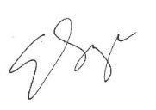 

Liz Savage Shelley Thorpe Stacey Craddock

Headteacher of Jennett’s Park CE Primary Family Support Worker Pupil Premium Lead

 2 | P a g e

