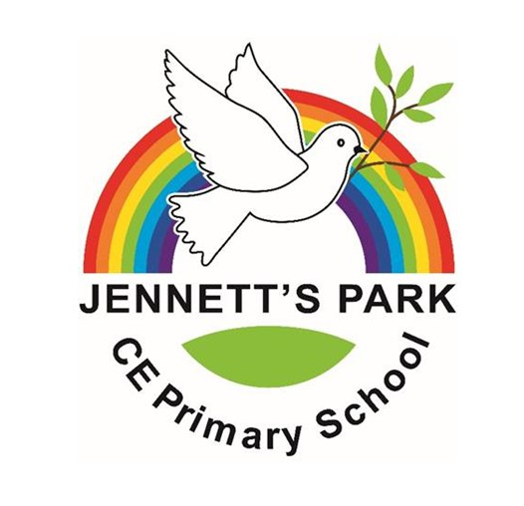
Jennett’s Park CE Primary School
Music Development Plan Summary

Overview
Detail | Information
Academic year that this summary covers | 2024/2025
Date this summary was published
Date this summary will be reviewed | September 2025
Name of the school music lead | Sharon Bruce
Name of school leadership team member with responsibility for music (if different)
Name of local music hub | Berkshire Music Trust
Name of other music education organisation(s) (if partnership in place) | Culture Mix  Rock Steady Music School

This is a summary of how our school delivers music education to all our pupils across three areas – curriculum music, co-curricular provision and musical experiences – and what changes we are planning in future years. This information is to help pupils and parents or carers understand what our school offers and who we work with to support our pupils’ music education.

Part A: Curriculum music
This is about what we teach in lesson time, how much time is spent teaching music and any music qualifications or awards that pupils can achieve.
At Jennett’s Park we deliver our music curriculum through ‘Sing Up Music’. This is a progressive scheme of work that meets the requirements of the Statutory Framework for the Early Years Foundation Stage, the National Curriculum for Music and suggested approaches of the Model Music Curriculum. Through the teaching of music our children develop skills in Singing, Listening, Composing, Performance and Instrumental Performance. Sing Up Music delivers a fully integrated approach to musical development allowing our children to learn, understand and use the interrelated dimensions of pitch, duration, dynamics, tempo, timbre, texture, structure and notation while experiencing music from a range of genres.
Every child throughout the school has weekly music curriculum lessons of between 30 and 60 minutes in length, which is recommended in the new National Plan for Music (2022).
We use Sing Up Music from Reception through to Year 6 (showing consistency and progression throughout the school). The lengths of lessons are as follows:
• 30 minutes per lesson for Early Years.
• 40 minutes per lesson for KS1.
• 50 minutes per lesson for KS2.
In addition to our weekly music lessons, all children take part in a 20 minute weekly singing assembly.
Through weekly lessons children experience a range of instruments, including tuned and untuned percussion. This is then further developed during Key Stage 2 when children have the opportunity to experience and learn a variety of different instruments.
Year 3 – ocarinas
Year 4 – ukuleles
Year 5 – Steel Pans
Year 6 – Steel Pans and keyboards
Ukuleles, Steel Pans and Keyboards are taught as whole class ensembles, and we are supported in this by Berkshire Music Trust and Culture Mix who provide specialist teachers.

Part B: Co-curricular music
This is about opportunities for pupils to sing and play music, outside of lesson time, including choirs, ensembles and bands, and how pupils can make progress in music beyond the core curriculum.
At Jennett’s Park we want all children to develop the self-confidence, skills, knowledge, and understanding to develop a lifelong love of music, whilst also providing a secure foundation that enables them to take music further should they wish to. This includes providing opportunities for children to progress further in their musical talents and interests.
We currently offer one to one or small group lessons in guitar, ukulele, and singing. This enables children to carry on developing their skills in an instrument that they have begun to learn in school or shown a particular interest in. These lessons are provided by Berkshire Music Trust and paid for by Parents and Carers. If your child is in receipt of Pupil Premium lessons provided by Berkshire Music Trust are discounted.
In addition to this, children also have the opportunity to learn an instrument with Rocksteady Music School. Rocksteady provides in-school fun and inclusive rock and pop band lessons for our school. This covers vocals, keyboards, drums, electric guitar and bass. Parents and carers pay for these lessons although they do offer a Bursary place.
We have a Key Stage 2 school choir, which is inclusive and open to all children. This runs free of charge.
For those wishing to learn outside of school, Berkshire Music Trust offers out of school instrumental tuition in a wide range of instruments after school and at the weekend. For more information on extra-curricular music lessons and ensembles outside of school, provided by Berkshire Music Trust please visit their website: Homepage - Berkshire Music Trust

Part C: Musical experiences
This is about all the other musical events and opportunities that we organise, such as singing in assembly, concerts and shows, and trips to professional concerts.
In addition to our weekly music lessons and singing assemblies all year groups take part in a musical show or concert that is performed to Parents and Carers.
Nursery – Christmas Songs
Reception – Christmas Nativity Performance (Also performed to the school), Termly sharing assembly to parents and carers.
Year 1 and 2 – Christmas Concert
Year 3 and 4 – Easter Performance (Also performed to the school)
Year 5 and 6 – End of Year Production (Also performed to the school)
Other events include a Key Stage 2 Carol Concert at St Michael’s Church, a Christingle Service led by Year 5’s and Harvest Festival Assemblies for Key Stages 1 and 2. Parents and Carers are invited to join us on each of these occasions.
Ocarina, ukulele and steel pan performances are run for families and peers throughout the year to celebrate and share instrumental learning. Every term, children involved in the Rocksteady Music School also perform in a concert for their parents/carers and peers to showcase their talents.
Choir have the opportunity to sing Christmas Carols to a local care home. In the Summer term children in Key Stage 2 children choir also take part in the Junior Music Festival. This is an event where they perform alongside a number of schools and live orchestra at The Hexagon Theatre.
Our children also have the opportunity to experience performances from musicians and theatre companies. Nursery and Reception watch a performance from Hobgoblin on a yearly basis and Key Stage 1 and 2 watch a pantomime at Christmas.
Year 5 and 6 visit a local Secondary School to watch their orchestra perform and the whole school also watch a performance of musicians from Berkshire Music Trust.

In the future
This is about what the school is planning for subsequent years.
- To continue working on instrumental provision so that children have the opportunity to progress their skills further in 1 or 2 instruments. For the next academic year, we will look at how we can develop the use of ukuleles in Year 5. We also aim to build in a progression from playing the ocarina to the recorder.

- To build on assessment strategies so that progress can be tracked in a meaningful way that is useful to children and teachers.

- To use the forthcoming CPD sessions from Berkshire Music Trust to assess and target future support for staff.

Further information
For information on how to develop as a musician outside of school, you might find the following useful:
Department for Education https://www.gov.uk/government/publications/music-education-information-for-parents-and-young-people
Berkshire Music Trust - Homepage - Berkshire Trust

